Feasibility Study Investigating the Production, Marketing and Sale of local Wild Venison in the Lower Wye Valley and southeast Monmouthshire

A report by The Deer Initiative
for the Wye Valley AONB Partnership

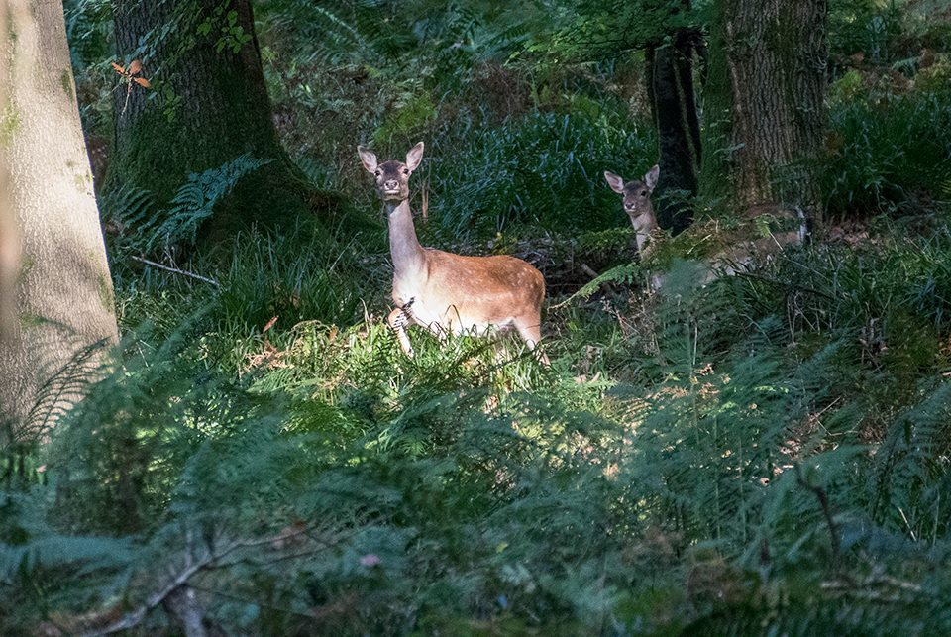
Photo credit – Gemma Wood
December 2017

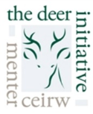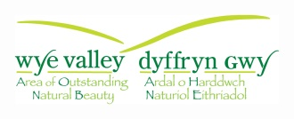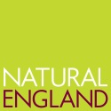
Contents
1. Introduction 4
1.1 Purpose of the study 4
2. Background 5
2.1 The Deer Initiative 5
2.2 Local Deer 5
2.3 Boar 7
2.4 Current Legislation 7
3. Purpose of Study 7
4. Methodology 8
5. Summary of Questionnaire Responses 9
5.1 Members of the Public 9
5.2 Stalkers 11
5.3 Butchers 13
5.4 Pubs and restaurants 14
5.5 Farmers Markets and Food Hubs 14
6. Conclusions 15
7. Information on other possible uses for venison 16
Appendix 1: Legislation 18
Appendix 2 Questionnaire 23
Appendix 3. Shot placement & carcass damage 24
Appendix 4. Health benefits of Venison. 26
(Information provided by Mrs Alison Benbow head of Nutrition at Worcester University). 26
Appendix 5. Wild/Feral Boar 27
Appendix 6 – Deer Best Practice Guide 29

Introduction
This report has been prepared by the Deer Initiative, commissioned by the Wye Valley Area of Outstanding Natural Beauty (AONB) Partnership, and funded by the Vale of Usk Local Action Group (LAG) under the Welsh Government Rural Communities - Rural Development Programme 2014-2020, Natural England and the Wye Valley AONB Sustainable Development Fund, a Welsh Assembly Government initiative in the Wye Valley AONB.

Purpose of the study
The study considers the current situation regarding wild deer managed in and around the Wye Valley AONB, where venison is processed and sold, and how it is marketed. It also investigates whether there are opportunities to develop a local market for wild venison and what stages of the supply chain need to be developed to ensure it can be supplied, processed, distributed and marketed locally.

The project focusses on the area in Figure 1, encompassing the lower half of the Wye Valley AONB from Symonds Yat in the north to Chepstow in the south and westwards across eastern Monmouthshire between The Hendre and Wentwood. This area has a high deer population and consequently the associated impacts on habitats are greater.

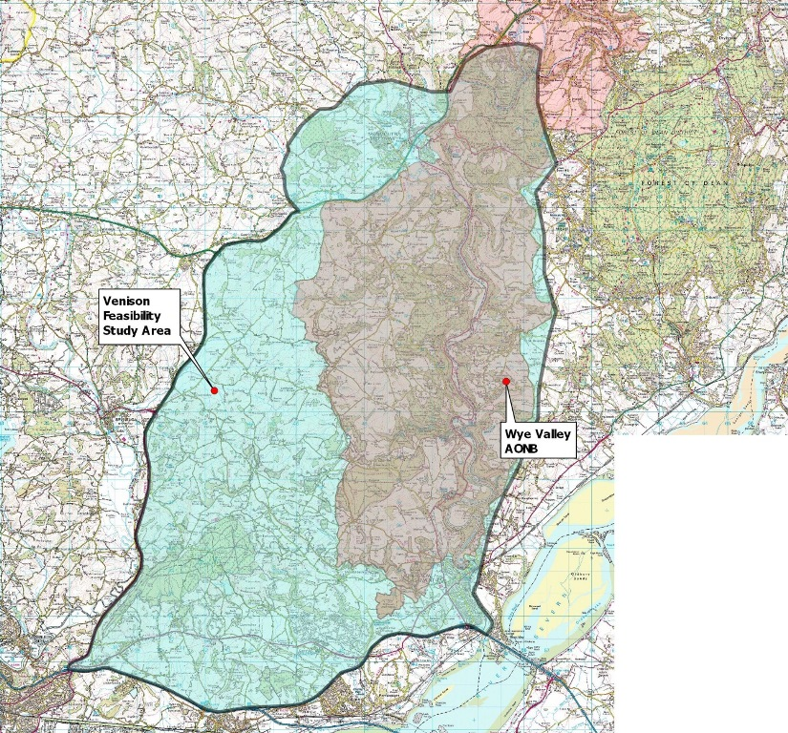

Figure 1 – Wild Venison feasibility study area

Background

The Deer Initiative
The Deer Initiative was established in 1999 with the aim of ensuring delivery of a healthy, sustainable wild deer population in Wales. With so little known about wild deer in Wales, the Deer Initiative has carried out extensive research, covering the distribution of Fallow, Roe, Muntjac, Red and Sika, and their impacts on forestry, agriculture and biodiversity.
The Deer Initiative provides advice and information on all issues relating to wild deer in Wales and their management, particularly through the use of Deer Management Plans and encouraging collaborative deer management through Deer Management Groups.

Local Deer
There are six species of deer found in the UK: Red and Roe are the only truly native species, while Fallow have been in the UK for at least 1,000 years and have now come to be considered naturalised, often considered as part of our natural heritage. The other three species; Sika, Muntjac and Chinese Water Deer (CWD) have all been introduced into the landscape in the last 150 years following a series of escapes and releases from various parks. The six species differ in their size, geographic distribution, abundance, population growth rate, behaviour and impacts.
Fallow is the main deer species that can be found in Wales. Roe, Red and Muntjac have become established in some areas and there is believed to be two small populations of Sika in the Cardigan area. The maps in Figure 2, below, show the current known distribution of these species in the project area, gathered through a previous Deer Initiative study. Each coloured square represents positive sightings of the relevant species.
It is widely accepted that deer are more abundant and widespread now than at any time in the past 1000 years. Deer populations have increased rapidly in recent decades due to a number of factors. These include:
- Milder winters
- Changes to agriculture such as the planting of winter crops
- Increased woodland cover
- Escapes and releases from parks and farms; and
- Greater connectivity between green spaces into urban areas
The current estimate for the number of deer in the UK is 2 million. However, due to the nature of deer as secretive and largely nocturnal wild animals, which are free to roam the landscape, it is notoriously difficult to give an accurate figure. Evidence for their increase in geographic range can be observed through their impacts on the landscape.
Due to the lack of natural predators in the UK, the role of humans in the food chain becomes more important. It is estimated that around 350,000 deer are culled each year in the UK, with road collisions as the second highest cause of mortality.
In Wales approximately 1,500 deer are culled annually. In the region of 900 of these are culled by Natural Resources Wales Wildlife Rangers. The number culled in the project area by private stalkers is probably as low as 150 to 250 per year. Despite this, in some areas this is not enough to keep a check on the rate of increase in deer populations which continue to expand.
As deer are still relatively limited in their distribution across Wales, their impacts are not felt as severely as they are in other parts of the UK, whether on agriculture, forestry or vulnerable habitats, as well as numbers of Deer Vehicle Collisions and the spread of certain diseases. However, as numbers increase, these impacts will grow and it is important to act to maintain the population at a sustainable level so that the positive benefits of the species may be felt, including the production of venison, revenue generated from stalking and potentially wildlife tourism.

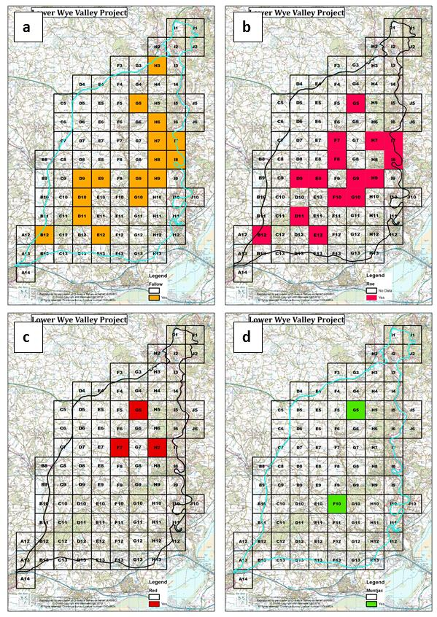

Figure 2 - The distribution of (a) Fallow, (b) Roe, (c) Red, and (d) Muntjac across the project area.
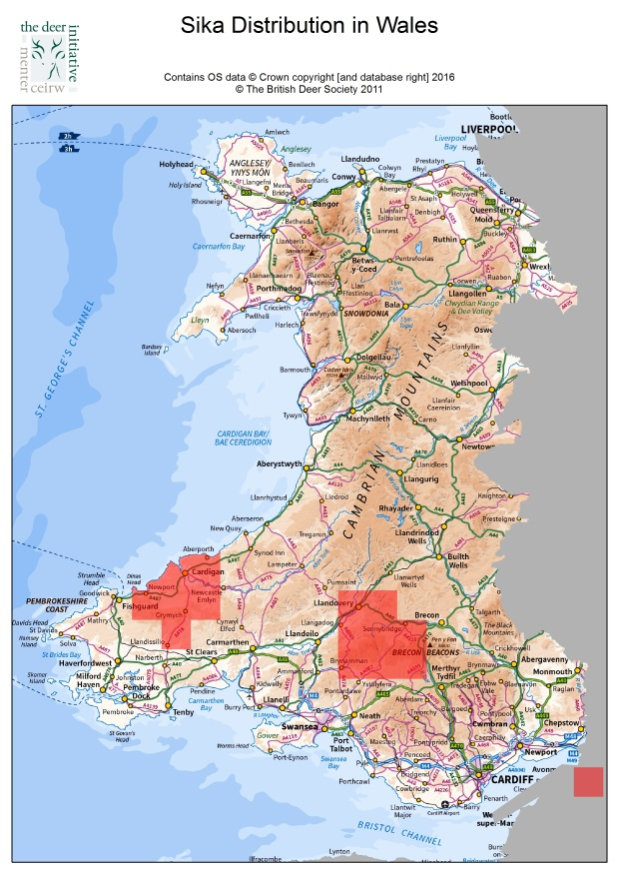

Fig 3 - The distribution of Sika across Wales.

Boar
In this report, feral wild boar will be included in the discussion. There is a large population of feral wild boar found in the Forest of Dean and High Meadow Woodland on the England-Wales border. The population has grown very quickly due to the abundance of food in and around the forested areas. While a breeding population appears to be currently restricted from expanding into Wales by the River Wye, it is thought to be only a matter of time before the population pressure in the Forest of Dean and High Meadow pushes greater numbers across the river and establishing a breeding population further into Wales.

Current Legislation
The regulations associated with the supply to others of wild deer carcasses and venison are complex. An interpretation of the regulations is given in the document “The Wild Game guide” developed by the Food standards Agency in partnership with the Wild Game Group which represents the wild game meat industry. There is a separate FSA “guide to the Food Hygiene and Other Regulations for the UK Meat Industry” for those who buy in wild game shot by others and produce meat from it. A useful Summary can be found at: http://www.thedeerinitiative.co.uk/uploads/guides/137.pdf
Full details of legislation relevant to wild venison can be found in Appendix 1.

Purpose of Study
The purpose of this study, commissioned by the Wye Valley AONB Unit, was outlined in the Project Brief and aims to:
- Investigate the current situation
  - Where deer carcases are currently being distributed
  - Is local venison being supplied into the local market, by whom and where to

- Research the potential demand for locally sourced wild venison.

- Investigate the opportunities for supplying wild venison into local outlets to include
  - Butchers
  - Restaurants and pubs
  - Food hubs and distribution centres

- Determine the interest among Lower Wye Valley Deer Group members and other local venison suppliers, to supply wild venison into the local food chain.

- Establish the location and availability of facilities for the storage, butchery and distribution of carcasses
  - Is there is an opportunity for linking with or cross promoting the supply of other local meat products, both farmed and wild, including wild boar.

- Establish the steps necessary to fill gaps in the existing local supply chain to include but not restricted to
  - Butchery skills
  - Distribution
  - Seasonality of supply.

- Raise awareness of the marketing opportunities to suppliers and sales outlets and outline the brand values.

- Make recommendations as to future steps needed to ensure sustainable supply and sales of locally sourced wild venison, including branding opportunities.

Methodology
In order to answer the questions set out in the project brief, it was necessary to ascertain information from a number of different stakeholders, individuals and groups. Questions were asked to people through both an online survey and face-to-face. The online survey was circulated to landowners, and other interested individuals via email through partner organisations. Face to face questions were asked in butchers, restaurants and pubs and to stalkers in the project area. The general public were also questioned in and around these outlets, as well as at the Monmouth Show.

Summary of Questionnaire Responses
In total 476 people responded to questions, the results of which are broken down here into the groups they represent.

Group | Total
Members of the public | 411
Stalkers | 17
Butchers | 12
Pubs and Restaurants | 36
Food Hubs | 0
Total | 476

Figure 4. Number of respondents by group
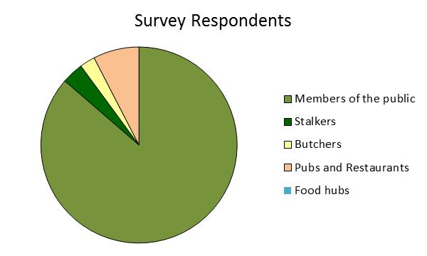

Figure 5. Summary of questionnaire respondents

Members of the Public
From the results of the survey carried out for this project nearly three quarters of those interviewed currently eat venison (70%), with the online survey suggesting that most (45%) eat venison only once or twice a year (see Figure 6). Some of the responses from those who do not currently eat venison were due to the respondents being vegetarian, though a number of people in the face-to-face interviews said that they do not like the taste, or that they find it too gamey, or complicated to cook.
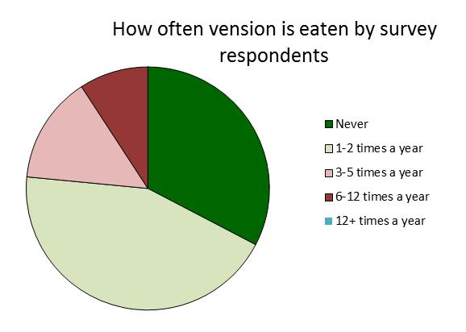

Figure 6. How often venison is eaten by respondents
It should be pointed out that although some supermarkets do sell venison most will only sell farmed venison, this is due to their requirement for continuity of supply and consistency in size of cuts. These requirements are rarely achievable when dealing with wild venison. It is also important to note that venison could include meat from any one of several species of deer all completely different in character and size.
There is a possibility that an increased awareness of how to cook venison to achieve the best from its natural flavour may increase sales, possibly through cooking demonstrations, or allowing people to enjoy venison at home using recipe cards made available as part of the follow up of the project.

The results also suggest that quite a high proportion of people (66%) are unaware of where they can buy Lower Wye Valley Venison and 41% of people don’t know how to cook it.
Recommendation 1 - Increase awareness of how to cook venison to achieve the best from its natural flavour will help increase sales, including through cooking demonstrations and recipe cards.

However, 73% of people interviewed face-to-face would be more likely to buy Lower Wye Valley Venison if the conservation benefits of eating it were highlighted, and 76% would also be interested in a scheme where the quality and provenance of the venison were guaranteed. The opinions shown here suggest a possibility for marketing or education making clear the ecological benefits of Local Wild Venison over traditionally farmed meats such as chicken beef and pork which may positively affect its long term sales.
Recommendation 2 – Establish a marketing &/or education campaign promoting and making clear the ecological benefits of Wild Venison over traditional farmed meats.

While most people interviewed are interested in a quality and provenance assured scheme, opinion on whether they would be willing to pay more for locally branded venison remains divided. Prices do fluctuate, but there is still a value to provenance, especially when general prices are lower. A slight majority of people (40%) said that they would pay more, followed by 34% who would not and 30% who are unsure.
With regards to the best place to sell Lower Wye Valley Wild Venison, 85% of people interviewed said that they would be more likely to buy Wild Venison and other local produce if they were all available in the same place, while currently most people buy their venison from a butcher (89%), others also buy it from farm shops (22%), restaurants or pubs (19%), supermarkets (9%), direct from the stalker (7%) or from friends (2%), see Figure 7. While there is a reasonable amount of variation in the answers, clearly a proportion of the public tend to go to their butcher to source their venison over other outlets, therefore a marketing campaign targeting butchers may prove to be the most effective method of increasing sales. All the butchers interviewed stated that due to limited space they would find it difficult to accommodate more venison on their shelves.
Recommendation 3 –Butchers are the main source of venison over other outlets, therefore a marketing campaign targeting butchers could prove to be the most effective method of increasing sales. However, it should be noted butchers may have limited space to store &/or display more venison.

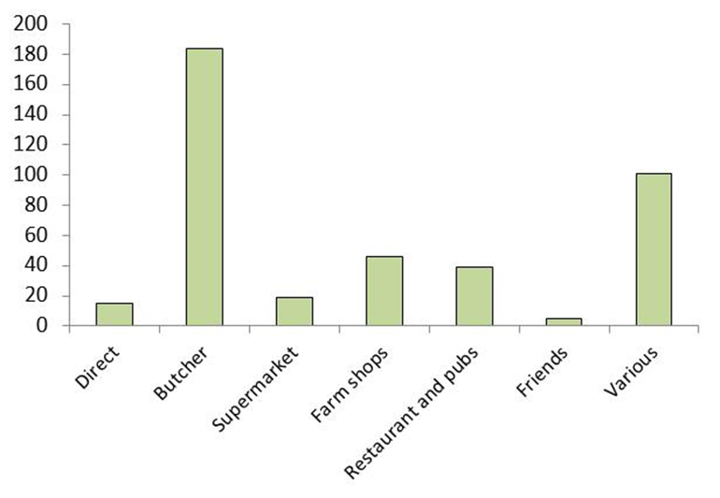

Figure 7 where most people currently buy their venison

Stalkers
Previous studies and discussions conducted by the Deer Initiative across the country on similar topics have struggled to get engagement from stalkers. Private stalkers can be reluctant to divulge information relating to their cull numbers, market outlets and the use of facilities. Questions, even when asked with the best intentions, may be met with suspicion or obfuscation. There appears to be genuine concern that if they share information with third parties that they may lose the ground they stalk, or that any money they make through stalking will be taxed and/or they may have to register as self-employed in order to continue selling venison. Stalkers do not necessarily cull deer purely for profit or to supply the food chain. For many the prime motivation may be population management and/or sport and recreation.
In total, there were 17 responses received to the online questionnaire from stalkers. Of these 17 stalkers, 16 consume some of the venison they produce themselves (94%) and 14 of them also supply (sell or give) their venison away to friends and family. Currently 82% of respondents sell their venison to a game dealer, 65% sell it to friends and only 12% sell it to a butcher. This is in contrast to the responses from members of the public, who appear to buy most of their venison from butchers. However, this may be explained by the low numbers of responses from stalkers.
It appears that most of the stalkers interviewed (76%) would actually prefer to sell their venison to a game dealer, with only 18% preferring butchers or to a local food hub. Only 6% of respondents would prefer to sell it to restaurants or to friends.
While the results suggest that not all of the stalkers may currently be interested in selling their venison for a profit, 65% of them would be interested in a scheme that guaranteed the quality and provenance of local wild venison, with 18% saying they would not be interested and another 18% remaining unsure. It was suggested that some type of a locally recognised logo could be displayed in retailer’s premises or in advertising leaflets.
88% percent of the stalkers believe that a premium could be charged for locally branded venison over an unbranded alternative, with 41% considering “Best Practice Venison” being the best branding opportunity. However, it may not be clear to the public what this actually means and could be considered ‘jargon’ unless followed by an extensive marketing campaign. The most popular suggestion was “Local Wild Venison” (29%), followed by “Wye Valley” (18%).
Recommendation 4 – More work is required to establish the most suitable ‘brand’ and how this would be administered in practice.

When questioning all levels of participants the one brand name which received the highest approval was “Local Wild Venison”. It is possible some type of badge system could be established through the Deer Management Group.

An opportunity for species branded venison may present itself as well, as all the stalkers interviewed currently cull fallow, and muntjac, which are commonly found across the country. As well as these two species, 59% cull Red, 53% cull Wild Boar, 29% cull Roe and 24% cull Sika. Stalkers will travel throughout the country and it may be, however, that certain species in this list are culled outside of the project area as there are, for example, few Sika currently found within Wales. This situation may change in the coming years, as feral wild boar are found on the English side of the River Wye and it is thought to be only a matter of time before the population expands across the border.
It remains unclear whether shared facilities would be useful for stalkers in the area, with 41% saying that they would use them, 35% saying that they would not and a further 24% saying that they are unsure. 82% of the stalkers interviewed currently have access to a larder and 88% have access to a chiller that can store between 2 and 100 carcasses, but the numbers here vary considerably. It is also unclear whether the larders and chillers comply with current Game Meat legislation requirements, and it is expected that a number of them do not.
There may also be difficulties in setting up and running such a shared facility within the law. The law requires that if more than one person supplies deer carcass’s into a game handling facility then it has to be registered as a Game Handling Establishment and therefore comply with all the relevant legislation.
In the past Deer Initiative staff have had conversations with game dealers and the like, who complain about the quality of some of the carcasses presented to them by stalkers. These complaints have been due to a number of aspects, but in particular shot placement has continually come up. The result of poor shot placement is often the cause of large portions of carcasses needing to be discarded and, in some limited cases, has resulted in entire carcasses being discarded (see appendix 3 for examples). While Best Practice dictates that stalkers should undertake a certain level of training in order to carry out their activities to the best of their abilities and so the deer or wild boar that they are culling are culled ethically, there is no legal requirement for this in order to hunt. The Deer Initiative can provide all levels of firearm shooting skills training and regularly run Best Practice evenings covering a wide range of deer/stalking topics for stalkers if they wish to attend. With increased or better training the amount of venison lost through wastage could be reduced, therefore opening more up to be sold in the market.
It is possible that there may be some benefit in raising awareness of the legislation through the creation of a document which is easier to navigate than the current Wild Game Guide, and perhaps one aimed directly at stalkers. Having a simplified document should remove any confusion surrounding the legislation which currently exists throughout the stalking community and lower the risk of stalkers unknowingly acting outside of the laws surrounding game.
The Deer Initiative have produced a “Best Practice” guide available on line for free. It covers all aspects relating to the six species of wild deer in the UK, the law regarding culling, inspecting, processing and all levels of legislation relating to deer.
(See appendix 6)
Recommendation 5 - Offering ongoing training, encouraging stalkers to continue to improve, shooting skills and use of appropriate bullets, should reduce the amount of venison being unnecessarily lost to the food supply chain.

Recommendation 6 - It is possible that there may be some benefit in raising awareness of the legislation through the creation of a document which is easier to navigate than the current Wild Game Guide, and perhaps one aimed directly at stalkers. Having a simplified document should remove any confusion surrounding the legislation which currently exists throughout the stalking community and lower the risk of stalkers unknowingly acting outside of the laws surrounding game. See Best Practice Guide above

Butchers
Twelve face-to-face interviews were conducted with local butchers who all sell venison both as raw meat and as other processed products. All of the butchers buy the meat as a whole carcass, rather than as individual joints. The source of these carcasses is unknown as none of the butchers filled in the online questionnaire, which is unfortunate.
It needs to be pointed out that when carrying out the interviews assurances were made to the interviewees that personal details would not be recorded or details of their business operations. It is vital to maintain the trust of these people for future associations with them.
All the butchers interviewed said that they find venison to be a seasonal meat, However it was pointed out they can freeze store it, then at a later date turn the venison into burgers and sausages for the barbeque market, plus a whole host of other special products unique to venison. Venison can be stored in the freezer for many months without losing its excellent quality, and flavour. This would also allow a larger market to be developed, as it is possible for retailers to buy more than can be sold in a few days, for example.
During the interviews with the butchers, it became apparent that many of them were not aware that if frozen, venison retains its excellent quality, which would allow it to be stored and then sold out of the hunting season, possibly for a higher value. This of course, is limited by storage space, and may be unfeasible in smaller premises where additional storage space would be needed.
Recommendation 7 – There is an opportunity to provide training / advice to butchers on the differences in taste between deer species, along with promoting the opportunity to freeze venison in a variety of forms for sale throughout the year. Additional storage may be required for butchers to make this practical.

There may be an opportunity to offer advice on the subtle differences between the different species along with producing advisory literature on freezing venison for later/summer use to take advantage of extending a market available to them.

Pubs and restaurants
The owners or managers of 36 pubs and restaurants that were likely to sell venison were interviewed. Twelve (33%) of them regularly include venison on their menu and a further eight (22%) include venison when they can obtain it. However, none of the restaurants have venison on their menu all year round.
Of the 20 restaurants that sell venison, seven of them sell Local Wild Venison (35%) and two of them sell venison which is farmed locally, though the particular farm they use actually falls outside the area that this project focuses on. Of the same subset of 20 restaurants, two of them buy whole carcasses (10%) and six (30%) buy specific cuts of meat or products such as burgers pies and sausages. It was not clear what the remaining 12 properties buy.
All of the pubs and restaurants interviewed would be interested in joining a quality and provenance assurance scheme (see recommendation 5 above)

Farmers Markets and Food Hubs
As far as we can ascertain there are currently no true food hubs within the project area or, indeed anywhere else in Wales. However, we spoke to two people who sell Local Wild Venison at local farmers markets who both said that they would be able to sell more venison if it were available, though both said that a large part of their business comes from outside the survey area.
In considering ways to develop a local supply chain for wild venison, the opportunity for a processing facility has been thought through. Such a facility could open up the market for a number of people; stalkers could use it to ensure that their venison stayed in the local market, supplying butchers, restaurants and members of the public with, local venison which could be traced back to its origin. If large enough it may be useful for supplying out of season venison through freeze storage, thereby addressing some of the seasonality that both restaurants and butchers identified as part of the limits of selling venison.
The conclusion drawn is that, due to several reasons it is very un-likely that such a facility would be viable.
• As things are the stalkers culling deer in the project area have already found outlets for the venison they harvest.
• There isn’t sufficient surplus raw material (deer carcasses) being harvested in the area to support such a venture.
• Even though there may be a need to reduce deer populations for the benefit of the woodland ecology a situation of diminishing supply is likely to soon arise. As the animal is wild, as more are culled, fewer remain. As the breeding population is reduced the detrimental effects to habitats diminishes as does the need to cull them.
Based on The Deer Initiative monitoring of the woodlands on the Welsh side of the River Wye there is now clear evidence that deer impact on woodland habitat are at a lower level now than they were ten years ago.
• It also needs to be understood that Approved Game Handling Establishment plants frequently lie idle during the summer (out of season) months and this alone places a huge burden on them to keep trained staff and the premises operational. It is not uncommon for one or two to close and not reopen in the UK each year.
• If such a plant were to be considered as a worthwhile and cost effective proposition, care would need to be taken to ensure that the sourcing of venison from the local area is carried out in accordance with the applicable legislation. The facility will need to be registered as an Approved Game Handling Establishment (AGHE) and all those supplying venison will need to be registered as food businesses (see Appendix 1 for the complexities of current legislation)
At present it is suspected that a proportion of stalkers are not registered as food business. Whether this is due to a lack of information on this, the information not being accessible or understandable, or in fact, more to do with an unwillingness to pay tax on the extra income they gain from stalking remains unclear. This however should be considered fully before undertaking any funding project for such a facility as if the reasoning is an unwillingness to interact with HMRC, it is unlikely the project will be successful.
Recommendation 8 – If a local food hub was developed, local wild venison should be included. Supply of local wild venison would need to be highlighted as an opportunity to potential wild venison suppliers, eg. through the Deer Management Group.

Conclusions
- While a purpose built facility to provide a location for stalkers to use to process their wild venison is unlikely to succeed, there are a number of opportunities around marketing, promotion and training to increase the proportion of local wild venison remaining in the local market.
- Overall, everyone interviewed face-to-face and those who completed the online survey seemed responsive to a quality and provenance scheme, which would guarantee local venison be sold in local markets. However, many areas of the potential market are unaware of the many positive reasons behind choosing to eat wild venison.
- Members of the public would benefit from education as to why venison is hunted in the UK, and how this benefits the natural ecosystem. This can be seen in the 73% of people who would be encouraged to buy Local Wild Venison if these benefits were highlighted in comparison to only 5% to whom this would make no difference to their opinion on the meat.
- The end consumers may also benefit from instruction in how best to prepare venison. While conducting the face-to-face interviews, it became apparent that while many people were aware how to cook venison, a large proportion were unsure how best to prepare the meat and stated that they have been unimpressed with the taste, whether too gamey or tough to eat. However, if prepared sympathetically to its natural flavour and cooked correctly venison is a very flavourful meat. This has been seen whenever live demonstrations have been carried out, the feedback has always been very positive from all sides and those that have tried the final product have been pleasantly surprised. Providing customers with recipe cards on how to prepare dishes that people wouldn’t normally try, placed in butchers or supermarkets for example to encourage people to buy venison over other meats and in doing so, have a positive experience with it, could have broad benefits.
- It is also clear that most consumers are not aware that there are huge differences in flavour and texture let alone size of joints between the different species as well as the health benefits of including venison in diets. Few people understand the nutritional benefits of wild venison. With the growing concerns over obesity and high cholesterol related problems it is quite possible that a venison based menu could be of benefit to many people (see appendix 4)
- While making recipe ideas available to members of the public, it may be worthwhile to provide a similar marketing scheme or tasting session to chefs in restaurants to encourage them to include a broader variety of venison recipes in their menus. Some chefs believe that marinating in red wine is a vital ingredient when cooking venison yet in reality white wine often produces a better flavour and often marinating is unnecessary. A tasting session would also be an excellent place to increase awareness of Local Wild Venison and its availability in local markets.
- It appears that butchers and restaurants are able to stock local Wild Venison, but there is no value currently being added to the product by stating its providence, promoting its health benefits or advising on how best to cook it. Promotional activity involving suppliers, retailers and consumers is required to encourage more people to eat wild venison, thereby encouraging retail outlets to stock more venison and give suppliers more reason to sell their venison locally rather than via game dealers. It is possible that if an advisory information pack were produced this could go a long way to dispelling many of the misunderstanding and myths relation to Wild Venison.

Information on other possible uses for venison
Other information which has been identified is that the general public’s appetite for cooking roast meals at home has changed in recent years. According to the Grocer Magazine 92% of the public shop at super markets. 79 million eat a ready meal per week with another 22 million consuming fast food type meals. We were unable to establish in this limited survey if any one makes venison ready meals. This situation could be the focus of a further study and possibly encourage a processor to set up such a facility selling wild venison into a wider market.
The production of a wide range of venison products such as pates, smoked venison, dry cured meats, terrines and many more similar products which can command a high price and ultimately increase demand for local wild venison. Many of these such products can add value of 10 fold to the base cost of the raw meat.
There is also evidence of a rapidly growing market for upmarket pet food which includes venison and wild boar. Some products being sold for as much as £23/kg this is 8.5 times the value of a whole carcass sold in the skin to an Approved Game Handling Establishment (AGHE). It is possible that some of the meat rejected as unfit for human consumption could go into this market. Not only would this provide an alternative outlet but could also help reduce the costs of disposal of waste for the AGHE, which has helped contribute to their over excessive overheads.
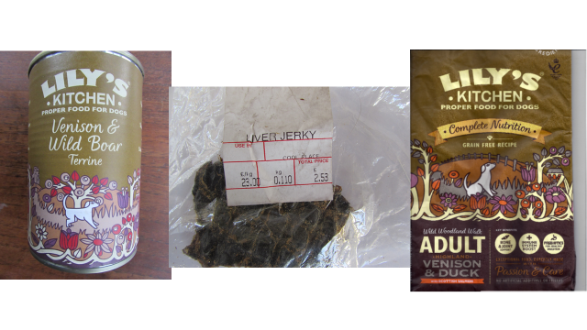
Another benefit of a possible pet food operation would be if run alongside an AGHE it could be an out of hunting season operation to keep the premises and some staff operational during close season months, again helping the business’s viability.
The national pet food market in 2016 was worth £2.8bn

Appendix 1: Legislation

Wild Game Meat
The key aim of current food legislation is to ensure that all food for human consumption is safe to eat. The Food Safety Act 1990 (as amended) provides the framework for all food legislation in Great Britain. The General Food Law Regulation (EC) 178/2002 is EC legislation on general food safety which sets general food law requirements, including establishing traceability of food, feed and food producing animals. The General Food Regulations 2004 (as amended) provides for the enforcement of certain provisions of Regulation (EC) 178/2002 (including imposing penalties) and amends the Food Safety Act 1990 to bring it in line with Regulation (EC) 178/2002.Since 1 January 2006, all game (which includes wild deer) supplied for human consumption must meet the requirements of Regulation (EC) No 852/2004, which sets general hygiene rules applying to all food businesses. In addition Regulation (EC) No 853/2004 which sets additional hygiene rules applying to certain businesses producing food of animal origin. Section V of Annex III of that regulation covers wild game supplied to and processed in Approved Game Handling Establishments (AGHEs). Food and meat legislation applies in different ways in different scenarios. The following list describes typical situations and gives a summary of the relevant legislation and recommended best practice.

Private Domestic Consumption
The regulations specifically relevant to wild game meat do not apply to private domestic consumption. Although the regulations are not applicable, the hygiene standards implied are relevant and it is recommended that they are still followed.

Supplying in-skin carcasses to the final consumer
A primary producer can supply in-skin carcasses, in small quantities directly to the final consumer or to local retailers that supply direct to the final consumer, under the “primary producerexemption”1. Under this exemption hunters are not a food business but are nonetheless responsible for supplying safe food under Regulation 178/2002. Rules on food traceability may be interpreted by the Local Authority as a need for your premises and/or vehicles to be registered. Carcass records should be kept to ensure traceability and it is recommended that carcasses are initially inspected by a trained person before being supplied. Temperature controls should be maintained and premises should comply with the requirements of Regulation (EC) No 852/2004. Advice on larder construction standards is in the Wild Game Guide1and the best practice guide “Larder Design”. Note: A business which buys up carcases from shoots and then sells them on to retailers cannot use the primary producer exemption, even if the quantities are small and the retailers local.

Supplying in-skin carcasses to an Approved Game Handling Establishment (AGHE)
If a hunter supplies in-skin carcasses to an AGHE, he/she must to be registered with the Local Authority as a food business (this includes a deer larder if used to store carcasses before they go to an AGHE and any vehicles used when supplying an AGHE). The hunter must comply with general hygiene requirements for primary production and associated operations. Any carcases taken to or picked up by an AGHE must normally have undergone an initial examination by a trained person’ and have a declaration attached, regardless of who shot the deer. The declaration must include such information as the species, sex, date, time and location shot, together with an identification number and a statement (signed by the trained person) either that the animal was free from any abnormal behaviour, carcass characteristics or environmental contamination, or describing any such features that were found. See 1 for a specimen tag. Pre-printed tags are available from the National Gamekeepers Organisation or from some AGHEs. An AGHE will not normally accept a carcass without a trained person’s declaration but may do so if it is accompanied by its head (not antlers) and heart, lungs and liver. A carcass should reach the AGHE as soon as possible. Temperature controls must be maintained and carcass records must be kept to ensure traceability. AGHEs may have their own specific requirements with regard to how they would prefer carcasses to be supplied. Premises must comply with the requirements of Regulation (EC) No 852/2004. Advice on larder construction standards is in the Wild Game Guide1and the best practice guide “Larder Design”.

Supplying venison (game meat) direct, in small quantities to final consumers or local retailers that supply direct to the final consumer, or for sale in own retail outlet
Such supply is possible under the “hunterexemption”1. This recognises the close relationship between the producer and the consumer. It is separate from the primary producer exemption and allows you to supply wild game meat. The hunter can benefit from this exemption if he/she shoots alone or if taking an active part in a hunting party. Both are exempt from having to develop their premises into an AGHE. All game must have been shot by hunting party members (it cannot be sourced from others) and can be prepared into meat by any one (or more) of the party. As with the primary producer exemption, only small quantities may be supplied, either direct to the final consumer or to local retailers that supply direct to final consumers (but not to retailers for supply to other retailers).It is the premises where the meat is prepared that has to be local to the retailers that are supplied and not the place(s) where the animal is shot. So the hunter can shoot on other people’s estates and then bring the game back to their own premises. The “retail exemption”1allows for supply of the same meat by the hunter or hunting party, through their own retail outlet. It is recommended that carcasses are initially inspected by a trained person before being further processed. The hunter must be registered with the Local Authority as a food business (this includes their deer larder if used to store carcasses and any vehicles used when supplying venison). The hunter must comply with general hygiene requirements and have in place a food safety management procedure based on Hazard Analysis Critical Control Points (HACCP) principles. Temperature controls and the cold chain must be maintained. Carcass meat and undressed carcasses must be effectively separated to avoid contamination, e.g.by using separate chillers or separate chiller areas in larger chillers), separate processing areas, or by in-skin carcass preparation and meat processing not being carried out at the same time in the same area. Records must be kept to ensure traceability. Premises must comply with the requirements of Regulation (EC) No 852/2004. Advice on larder construction standards is in the Wild Game Guide1and the best practice guide “Larder Design”. Note: Businesses which buy in or use carcasses from elsewhere cannot make use of this exemption and must become an AGHE.

Other routes of supply
These are dealt with in the FSA Wild Game guide1which also has a useful question and answer annexe.

Definitions
Approved Game Handling Establishment (AGHE)
- An establishment, approved by the Food Standards Agency, for processing wild game for general sale both within the UK and for exports.

Final consumer
- Ultimate consumer of a foodstuff who will not use the venison as part of any food business operation or activity.

Food Business Operator (FBO),
Registration
- To protect public health, competent authorities need to be able to identify those who are operating a food business, the address where the business is located and the activities that are carried out, this is known as “registration”. Existing forms of registration, e.g. agricultural holding registers may meet the requirement.

Registration is required for:
- Shooting/stalking estates (with or without a game larder) supplying all their in-fur/in-feather
Game for private domestic consumption or that come under the exemption for supply of small quantities of in-fur/in-feather game direct to the final consumer or to local retailers.
- Shooting/stalking estates where at least some of the game shot there goes to an AGHE (even if this is carried by a transport operator);
- individual hunters or hunting parties operating an in-fur/in-feather game larder where at least some of the game goes to an AGHE;
- Collection centres for in-fur/in-feather game where at least some of the game goes to an
- AGHE;
- Businesses transporting in-fur/in-feather game from where it is shot to one or more AGHEs; those taking advantage of the hunter exemption to produce prepared game meat (i.e. wild game that has been skinned or plucked) from the game you either shot as an individual hunter or was shot by the hunting party of which you were an active member).
- Any business buying game for onward sale (with or without processing it into wild game
meat), unless they are required to be approved as an AGHE instead.

Terminology

Game meat

- Once the skin has been removed from a “primary product” carcass it becomes “Game
Meat”.

Hazard Analysis Critical Control Points

(HACCP)
- The HACCP system is internationally accepted as the system of choice for food safety management. It is a preventative approach to food safety based identifying hazards and critical control points, and establishing, verifying, reviewing and recording food safety procedures and measures.

Hunting/Hunter

– In this context hunting is a legal method of killing wild animals. The “hunter exemption” described in this guide applies to individual hunters and/or active members of hunting parties whether acting individually or as a group.
Larder

- Premises used for keeping killed wild game, where primary products are stored prior to onward transport or processing.

Local Supply/Local
-Refers to the supplying establishment’s county, any neighbouring counties or a radius of 30 mile/50km, whichever is greater. Also includes mail order and internet sales to the final consumer wherever they may be sent.
Premises
– Applies to any buildings, whether permanent or temporary, and mobile sales vehicles.
Primary Producer
The EU food hygiene regulations regard shooting wild deer, “hunting”, for human consumption as a primary production activity. An individual who shoots deer alone, a hunting party or an estate which organises shooting are all primary producers.
Primary product
– Primary products in the wild game sector are the products of hunting – i.e. in-skin and in-feather game that has undergone no more than any necessary preparation that is part of normal hunting practice. For deer the maximum level of preparation is an in-skin carcass, empty of internal organs, with the head and feet removed.
Private domestic consumption
- This would typically apply to deer that you have shot yourself or venison you have bought or have been given, whether still in-skin or as oven-ready carcases or game meat, which you will eat yourself or share with family or friends. The key point is that it is not for supply to anyone else as part of a food business. To explain where private domestic consumption ends and running a food business starts, the EU food hygiene regulations speak of “undertakings, the concept of which implies a certain continuity of activities and a certain degree of organisation.”
Small Quantities
- Has no absolute figure set, the quantity is intended to be self-limiting.
Temperature controls
Food business Operators (FBO’s) are responsible for the safety of the food they supply. Freshly shot carcasses should cool to no more than 7°C within “a reasonable time after killing”. This period is not defined but, for example, overnight storage is almost certain to require active chilling unless the temperature of the storage facility can be relied on to be below 7°C because the ambient (outside) temperature is low enough. There is a general concept of maintaining the “cold chain” whereby a carcass cools progressively to below 7°C and neither it nor meat from it is subsequently allowed to rise above that temperature. In-skin carcasses must not be frozen.
If transportation of carcasses or meat is to be prolonged, refrigerated transport will be required.
Even where FBO registration is not required it is strongly recommended that these temperature controls are
adhered to.
Traceability
– Regulation 178/2002 applies to all food business operators including primary producers.
Even those that benefit from exemptions, and covers the whole food and feed chain. The Regulation uses the principle of “one step back and one step forward” so that food can be traced along the supply chain. FBO’s are required to have in place systems and procedures that allow for traceability information to be made available to competent authorities on demand. Copies of invoices and larder records may be sufficient. Key information is the name and address of the supplier/customer, the date and the nature of the products. Final consumers do not have to be individually identified. However, it is useful to record how much game is supplied direct to final consumers.
Trained Person
– Individual who can produce evidence of training to cover the requirements of Regulation (EC) No 852/2004, and Regulation (EC) No 853/2004 as they apply to wild game, see below. An approved qualification such as the updated Deer Stalking Certificate Level 14 or the Certificate in Wild Game Meat Hygiene (large game) 3, is the most robust way in which stalkers can show that they have the appropriate knowledge.
Wild Game
Meat derived from wild free living animals or bird hunted for food or sport,
Note: wild game must only have been killed by hunting. Deer killed by any other means e.g. road traffic accidents, must not be supplied for human consumption.
Further Info
1 FSA Wild Game Guide - http://www.food.gov.
UK/multimedia/pdfs/wildgameguide1oct08.pdf
2 FSA Meat Hygiene Guide - http://www.food.gov.
UK/foodindustry/meat/guidehygienemeat
3 LANTRA awards - http://www.lantra-awards.co.uk/
training/wildgamemeathygiene.aspx
4 Deer Stalking Certificate - http://www.dmq.org.uk/

Appendix 2 Questionnaire
The Wye Valley Wild Venison survey questionnaire.

Questions to Butchers/Meat suppliers.
1. Do you sell local wild venison (LWV) if so what species.
2. Do you sell it is it as raw meat or do you make it into other products, if so what.
3. What form do you buy it in at, whole carcass or specific cuts?
4. Do you find it is a seasonal meat?
5. Would you be interested in being part of a quality and provenance assured supply chain.
6. If you don’t sell LWV would you like information about it.

Question to Pubs and restaurants.
1. Do you have local wild venison on your menu?
2. Do you have LWV on your menu all round, if not why not.
3. Do you look to source your venison from a local supply?
4. If you buy LWV what form do you buy it in, ie whole carcass or joints?
5. Would you be interested in buying LWV as part of a quality and provenance assured supply chain.

Questions to the general public.
1. Do you buy LWV?
2. Do you know where to buy LWV?
3. Do you know how to cook venison?
4. Would you be more likely to buy LWV if its quality and provenance were guaranteed through an assurance supply chain?
5. Would you be interested to learn more about the sustainable management of wild deer and the benefits to the woodland eco systems?

Questions to Farmers markets and Food Hubs.
1. Do you sell LWV?
2. Do you get asked for wild venison?
3. Would you consider selling LWV if its supply, quality and provenance could be guaranteed under a supply chain?

Appendix 3. Shot placement & carcass damage
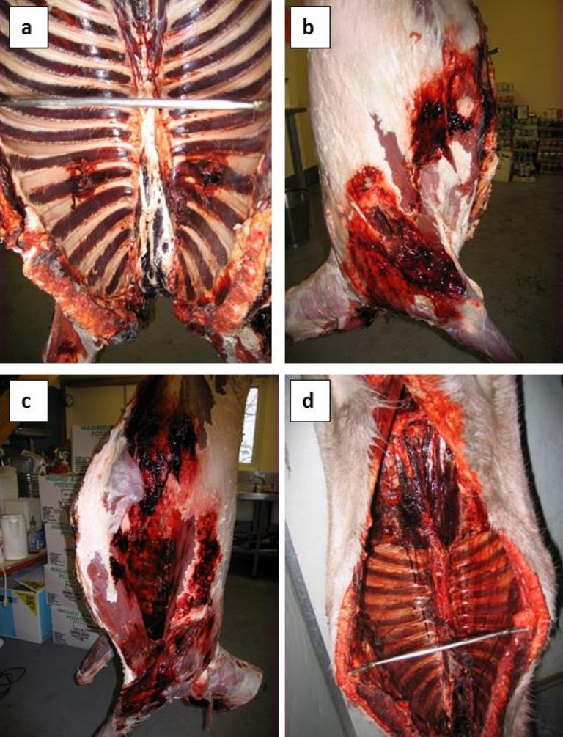
Figure 6. Bullet damage caused by poor bullet placement and poor levels of presentation; (a) view inside the body cavity, (b & c) damage uncovered once the skin is removed, (d) poor larder practice
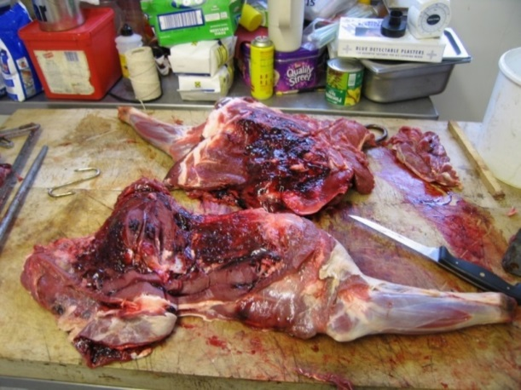
Haemorrhaging on the inside of shoulders due to bullet shock.
Is head shooting the answer?
The images below clearly show how badly wrong attempts at head shooting can go, resulting in unbelievable suffering of the animal. All the deer shown below were eventually humanely dispatched several days after the first attempt to cull them had been made.
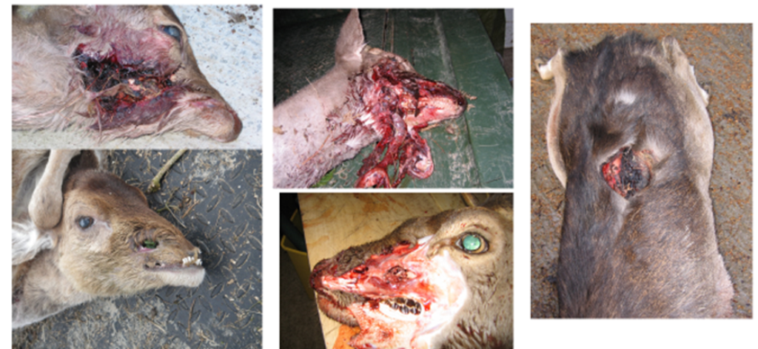

Appendix 4. Health benefits of Venison.

(Information provided by Mrs Alison Benbow head of Nutrition at Worcester University).
Health benefits [1] summarised as being superior in nutrient composition to beef and particularly beneficial due to its lower saturated fat content and in farmed venison three times the poly unsaturated fats levels.
Venison delivers more bioavailable Iron than other red meat as well as being a good source of Thiamine, Riboflavin, Phosphorous, Zinc and Selenium. The saturated fat content is lower at approximately 75% less saturated fat with approximately 30% less cholesterol than beef. The lower saturated fat means that per gram there are less calories, again depending on cut, around 30% less.
For example
Comparison of Venison vs beef [2]
 | Calories/ kcal | Saturated fat/g | Iron /mg | Calcium/mg
Venison | 128 | 0.7 | 3.5 | 5.1
Beef | 225 | 4.9 | 3.1 | 10.2

1] Bureš, D., Bartoň, L., Kotrba, R. and Hakl, J. (2015), Quality attributes and composition of meat from red deer (Cervus elaphus), fallow deer (Dama dama) and Aberdeen Angus and Holstein cattle (Bos taurus). J. Sci. Food Agric., 95: 2299–2306. doi:10.1002/jsfa.6950
[2] Nutrition data http://nutritiondata.self.com/

Appendix 5. Wild/Feral Boar
A brief study into all aspects of controlling feral wild boar in the project area was carried out by the Deer Initiative in 2015 as part of a fact gathering exercise relating to who was culling boar, where were the carcass’s going to and at what level of compliance to the regulations were the animals being culled and possibly sold on to consumers.
This survey is designed to investigate a number of issues in the Forest of Dean area:
- Do stalkers / hunters process their own carcases
- Are the carcases tested for Trichinella
- Are stalkers / hunters interested in using a communal larder facility/collection centre
- Are existing processors following the required legal and Best Practice requirements
- Are existing processors in favour of supporting a kite mark of quality assurance for use on final packaging?
- Are stalkers / hunters interested in training connected with culling/processing wild boar?

Having visited the forest area to meet with a broad cross section of as many parties involved as possible and asking a standard set of questions I have formed the following conclusions;

- In the professional sector the Forestry Commission is by far the largest operating and all of their culling /larder operations are carried out to the highest standard and comply with all legal requirements for the handling, storage, testing and sale of wild boar.
- A large majority of stalkers were reluctant to divulge detailed information, so in an effort to gather information I assured all those I spoke to that I would provide complete anonymity.
- It appears that a very large quantity of wild boar meat is going into the food chain with little record of where they come from, who has done the cull or when the cull was performed.
- In the private sector it appears that more than 75% of those questioned are selling carcasses into the food chain using the “hunter exemption small quantities” legislation for the sale of wild game meat, i.e. into a local market.
- However, it seems that these carcasses are being sold skinned and very few of these hunters are registered as a ‘food business’, and it appears that none are being tested for Trichinella.
- It appears the only carcasses these hunters sell to AGHEs are the larger older pigs that are not required by the immediate local market.
- Two of the main reasons found for operating in such a manner are:
- It is felt that if the hunter were to register as a food business the local authority would then require local business rates on the facility,
- The hunter would fear the HMRC would want a share of the proceeds.
- It also seems that deer are going into the food chain the same way and for the same reasons.
- This situation is clearly illegal and annoys those who are registered and who comply with the legal requirements.

Evidence gathered suggests that those performing the cull can range from individual hunters taking as few as 2 or 3 animals per year up to some individuals shooting over 40 per year.
When asked whether they would support/use a communal larder facility, approximately 50% of the stalkers had access to some sort of cold storage unit and only a small number said that they would consider using a one available communally.
Of the processors interviewed most felt a kite mark of “quality and legal assurance” would be of benefit to prove that the meat has come from a reputable origin, however few thought it would lead to an increase in retail value as at the moment supply falls well short of demand.
As far as I could establish a large percentage of the boar sold to an AGHE were sold out of the forest area.
Most people interviewed expressed an interest in taking part in some sort of training although few made any suggestion as to the content of the training required.
It needs to be understood that the harvesting of wild boar in the private sector in the Forest of Dean area is a very complex and secretive operation. The motivations for those performing the cull are a complex mixture of population management, harvesting to supply the food chain, and trophy hunting.

Appendix 6 – Deer Best Practice Guide

