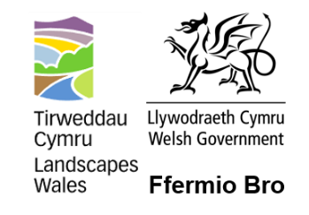
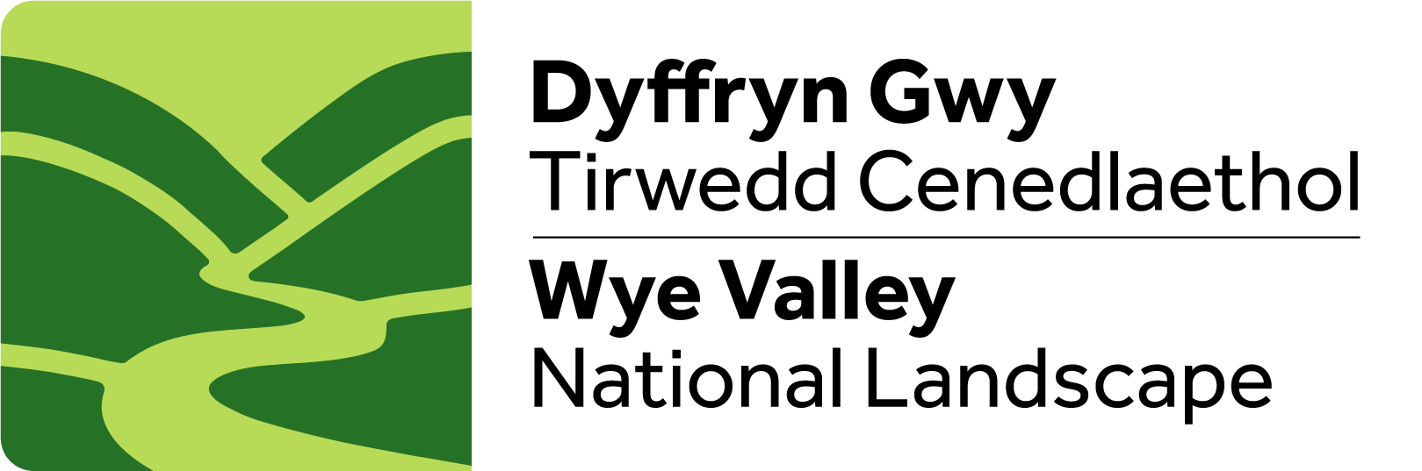Ffurflen Datgan Diddordeb Ffermio Bro
Ffermio Bro Expression of Interest Form

Angen cymorth i lenwi’r ffurflen hon?  Cysylltwch â’r Tîm Ffermio Bro fydd ar gael i’ch cynorthwyo:  Farming2@wyevalleyaonb.org.uk | Need help with filling out this form?  Contact the Ffermio Bro Team who will be able to support you:  Farming2@wyevalleyaonb.org.uk
Enw Llawn
Full Name
Cyfeiriad
Address
Rhif ffôn
Phone number
Cyfeiriad e-bost
Email address
Os yw hwn yn gais ar ran grŵp o ffermwyr, rhestrwch enwau’r ffermwyr a chyfeiriad eu ffermydd.

If this is a farmer group application, please list the names of the farmers and the address of their farms.
2. A oes gan bob ymgeisydd Rif Cyfeirnod Cwsmer (CRN) Taliadau Gwledig Cymru (RPW)?  2. Do all applicant have a Rural Payments Wales (RPW) Customer Reference Number (CRN)? | ☐ Oes | Yes  ☐ Nac oes | No
3. Disgrifiwch y prosiect.
(uchafswm 500 gair)

3. Describe the project.
(maximum 500 words)
4a. A fydd y prosiect yn cyflawni er lles natur ac ecosystemau?  4a. Will the project support nature and ecosystems? | ☐ Bydd | Yes  ☐ Na fydd | No
4b. Disgrifiwch sut bydd y prosiect yn fuddiol i natur. (uchafswm 500 gair)

4b. Describe how the project will deliver for nature. (max 500 words)

5a. A yw’r prosiect yn cynnwys nifer o ffermydd?  5a. Does the project involve multiple farms? | ☐ Ydi | Yes  ☐ Nac ydi | No
5b. Os nodwyd ‘Ydi’ i 5, ym mha ffordd y bydd y prosiect yn cynnwys nifer o ffermydd?

5b. If you noted ‘Yes’ to 5, in what way will the project involve multiple farms?

6. A fydd y gwaith i gyd wedi’i gwblhau erbyn 1 Mawrth 2026?  6. Will all works be completed by 1 March 2026? | ☐ Bydd | Yes  ☐ Na fydd | No
7a. A oes angen caniatâd/trwyddedau gan Cyfoeth Naturiol Cymru neu Awdurdod Lleol ar gyfer y prosiect?  7a. Does the project require consents/permissions/licences from NRW or a Local Authority? | ☐ Oes | Yes  ☐ Nac oes | No  ☐ Ddim yn siwr | Not sure
7b. Os oes i 7a, pa ganiatâd/trwyddedau sydd eu hangen? Am ragor o wybodaeth, cysylltwch â'ch Cynghorydd Ffermio Bro lleol.

7b. If yes to 7a, which consents/licences/permissions are required? For more information, contact your local Ffermio Bro Advisor.

8a. A oes unrhyw gyllid arall wedi'i dderbyn o'r blaen ar gyfer y prosiect arfaethedig?  8a. Has any other funding been received before for the proposed project? | ☐ Oes | Yes  ☐ Nac oes | No
8b. Os oes i 8a, rhowch fwy o fanylion.

8b. If yes to 8a, please give more details.

Enw
Name
Llofnod
Signature
Dyddiad
Date

Beth i’w wneud nesaf?  Dychwelwch y ffurflen hon i:  E-bost i: Farming2@wyevalleyaonb.org.uk  Drwy’r post i:  Swyddog Fermio Bro  Wye Valley National Landscape Team  Wye Valley AONB Office  Hadnock Road  Monmouth  NP25 3NG | What to do next?  Please return this form to:  Email to: Farming2@wyevalleyaonb.org.uk  Postal to:  Fermio Bro Officer  Wye Valley National Landscape Team  Wye Valley AONB Office  Hadnock Road  Monmouth  NP25 3NG

